**Kaipara District Plan Review – Exposure Draft**

**MANGAWHAI MATTERS SUBMISSION**

**3 October 2022**

**Summary**

**MMI submits that:**

* The provision for residential zones is excessive: at the recent rapid growth rate there is provision for some 50 years supply;
* The number of residential zones and the density rules are excessive and will reduce flexibility and resilience;
* The amount of business land [commercial and industrial] is inadequate relative to the residential capacity proposed;
* The urban growth provided for will significantly compromise the character of Mangawhai and its important and sensitive environmental values. It cannot be supported given physical and fiscal limits on the capacity to provide appropriate infrastructure, including reticulated water supply, wastewater treatment and disposal, and transport connections.
* The form of rural subdivision is inappropriate for achieving economic land use, accommodating demand for rural settlement, protecting and promoting biodiversity, and enhancing the standard of runoff within the Mangawhai harbour catchment.

In short, our view is that the exposure draft does not provide for incremental growth within the constraints of the locality, but instead anticipates an unsustainable transformation of Mangawhai which cannot be achieved without excessive environmental, economic, and social costs.

**We propose that:**

1. The zones as set out are critically reviewed with a view to the sustainability and viability of their development, and a better balance among them;
2. The differentiation among and rules of residential zones be reviewed to provide flexibility;
3. The Council consider amendments (including but not limited to those suggested in this submission) to:

* Enable growth to proceed steadily but not beyond the limits of sustainability;
* Ensure economically and fiscally responsible supply of physical and community infrastructure;
* Protect the natural and built and social character of Mangawhai;
* Protect the sensitive and valued coastal environment;
* Rationalise rural development.

The balance of this submission explains our concerns and proposes areas for review and amendment. Some specific proposals for amendment are suggested under three headings: the natural and physical environment, town settlement, and rural settlement.

**Background**

In our submission to the District Plan Review Discussion Documents, MMI stated that:

Alignment with central and regional mandates is most likely to achieve their objectives “if informed by and reflecting local conditions, needs, and capacity”.

Having considered the land and resource use provisions in the Exposure Draft MMI submits that they need to be modified to reflect Mangawhai’s circumstances, challenges, and prospects.

**Mangawhai Issues**

The local issues informing our submission are:

* The distinctive and valued character of the **physical environment**:
  + A highly valued coastal setting defined by hills, harbour, dunes, and open coastline;
  + A quality harbour that supports diverse marine and avian species;
  + A settlement shaped and defined by the constraints of the marine setting, a built environment reflecting its coastal heritage, and a series of tree-clad hills and ridges running largely parallel to the coast and backed by a diverse rural hinterland;
* The growing challenge of **climate change** to Mangawhai through rising sea levels, volatile weather marked by periods of prolonged drought, high winds (with increasing frequency from the east), and occasional, intensive coastal rainstorms;
* The **infrastructure constraints** associated with limited local water supply, the high cost of expanding sewage treatment and disposal, and a legacy of local and rural roads of limited capacity and often limited connectivity.
* The limits to **sustainable development** imposed in large part through the foregoing matters.

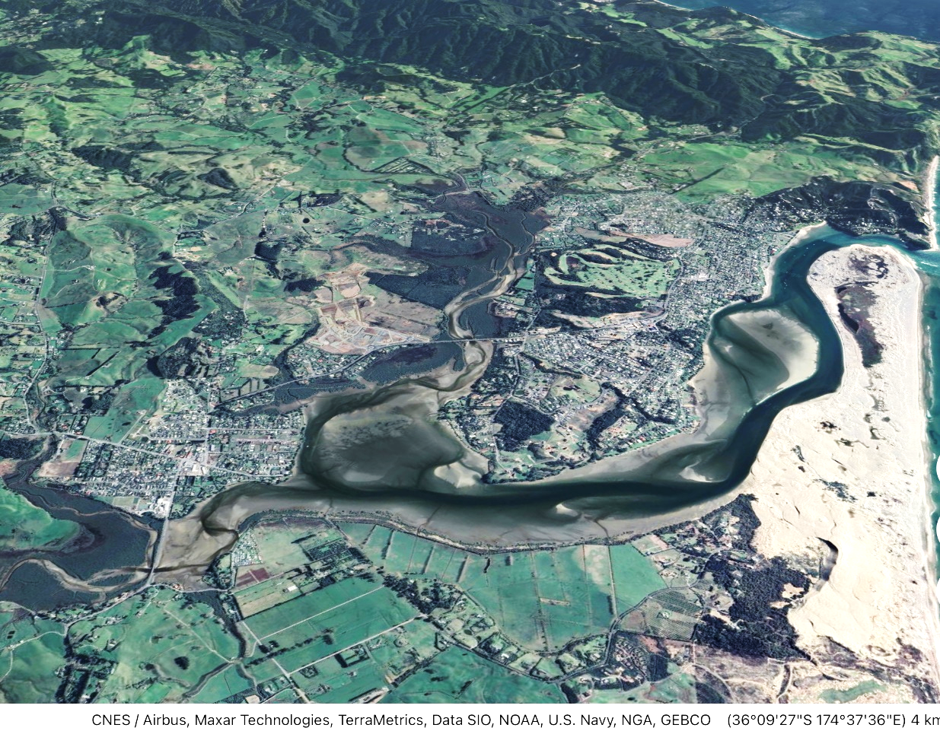

**A Misplaced Growth Imperative?**

We note that the strategic vision expressed in the Exposure Draft is based on “*growing a better Kaipara*”. Accommodating high growth dominates the review as it relates to Mangawhai. This is illustrated by comparing zones between the Operative District Plan and the Exposure Draft:



The expansive stance of the draft represents a major shift from the ODP and the more measured approach proposed in the 2016 Community Town Plan (See Attachment One). Our experience in considering and contesting Plan Change 78 suggests that the 2016 approach is more consistent with Mangawhai’s distinctive coastal and rural setting and environmental and infrastructure constraints.

While new zones to protect open and recreational space are supported, the major effect of the land use proposals in the above table is to dramatically increase population capacity. Residential zoning is expanded to cater for rapid growth with no obvious reference to either ongoing changes in the demographic drivers that might support that growth or the capacity of the locality to sustain it.

**Expanding Settlements**

Objective UFD 06 Urban Expansion is misnamed as it presupposes the spread of existing rural settlements and their development as *urban* areas. It appears guided by a “containment” philosophy more appropriate to large towns and cities (where high-capacity public transport connectivity is required to offset the resulting congestion) than small rural and coastal settlements.

A measured degree of consolidation and intensification and limited spatial expansion may be appropriate in Kaipara’s centres to provide for growth that is sustainable with respect to affordable infrastructure and environmental capacity, and is economically and fiscally sensible. Within these constraints the objective should be to maintain and promote the attractive, quality, small town environments of Mangawhai, Kaiwaka, Maungaturoto and Dargaville.

Growth beyond them can be provided for in other ways. In fact, a substantial share of Kaipara’s growth has been in rural areas. Rural lifestyle and small-lot subdivision will continue to play a role, and this should be subject to provisions that reflect the character and capacity of the land.

It may also be appropriate to enable new, small-scale, strategically located rural settlements at strategic locations, again adopting sustainability-based principles, where the physical environment and connectivity allows, ideally, building on an existing core of economic and settlement activity.

**Urban Zoning for Mangawhai**

Undeveloped capacity in Mangawhai Central and 205ha provided for in the Draft provide over 260ha additional residential land, sufficient for a population of well over 20,000 compared with the 4,000 in the Village and the Heads in 2021 (Attachment Two), a five-fold increase. Over the 15 years since 2006 the joint population of the Heads and Village has increased by around 2,600 people, a modest 200 persons/year. Rapid growth between 2013-2021 averaged 260 persons/year. Even at this rate, it would take some 55 years to absorb an additional 16,000 residents.

MMI submits that the proposed provision of residential land is excessive and unwarranted, and will significantly compromise the character of Mangawhai, given the town’s important and sensitive environmental values and limitations on the ability to provide appropriate infrastructure.

The latter includes limits on and the costs of expanding reticulated water supply, wastewater treatment and disposal, and urban transport connectivity. The physical characteristics of Mangawhai mean it is inappropriate to provide for expansion to cope with multiples of current demand.

For example, despite providing for alternative walking and cycling connectivity, the vehicle traffic generated by an uptake of the zoned capacity will inevitably be concentrated on very few roads - mostly existing routes, resulting in significant additional congestion and the need to widen existing arterial/collector roads to four lanes throughout the town and between the town and the State Highway. Noteably, most existing arterial roads within Mangawhai are flanked by sensitive residential and recreational activities[1].

The amount of residential land provided for does not align with other draft zone provisions. Even with low labour force participation, the proposed commercial and industrial zones (including land under development in Mangawhai Central) total 26ha, well short of what will be required to cater for the labour force needs likely to be associated with the residential capacity (Attachment Two). Such an imbalance in land use is likely to inflate business land prices and discourage employment-related investment, promote outbound commuting, or simply impede growth.

Plan Change 78 has highlighted that the supply and cost of infrastructure will severely constrain the sustainable level and rate of development, stretching the timeframe for the uptake of capacity out further and raising the prospects of zoned land lying idle or underutilised for the foreseeable future.

**MMI Submission**

**While recognising the value of over-zoning to allow for long-term options, we submit that the residential capacity provided is excessive and unsustainable in the Mangawhai environment. High levels of growth are neither required nor inevitable, with better options to accommodate urban growth in south-east Kaipara than over-concentrating it in the sensitive Mangawhai environment.**

We propose that:

1. The zones as set out are critically reviewed with a view to the sustainability and viability of their development, and a better balance among them;
2. The differentiation among and rules of residential zones be reviewed to provide flexibility;
3. The Council consider amendments including those suggested in this submission) to:

* Enable growth to proceed steadily but not beyond the limits of sustainability;
* Ensure economically and fiscally responsible supply of physical and community infrastructure;
* Protect the natural and built and social character of Mangawhai;
* Protect the sensitive and valued coastal environment;
* Rationalise rural development.

Specific provisions are proposed below under three headings: the natural and physical environment, sustainable town settlement, and rural settlement. We propose also that the objectives and policies for the residential and rural zones be reviewed and amended as appropriate to relate to these specific provisions.

**1 The Physical and Natural Environment**

* Protect prominent landscape features from development using methods such as a genuine (e.g., 4,000m2) large lot zoning and ridge line protection overlays and limiting development and clearance in sensitive areas (coastal and elevated bush landscapes).

**The Old Waipu Road ridge backdropping Mangawhai Central[2]**

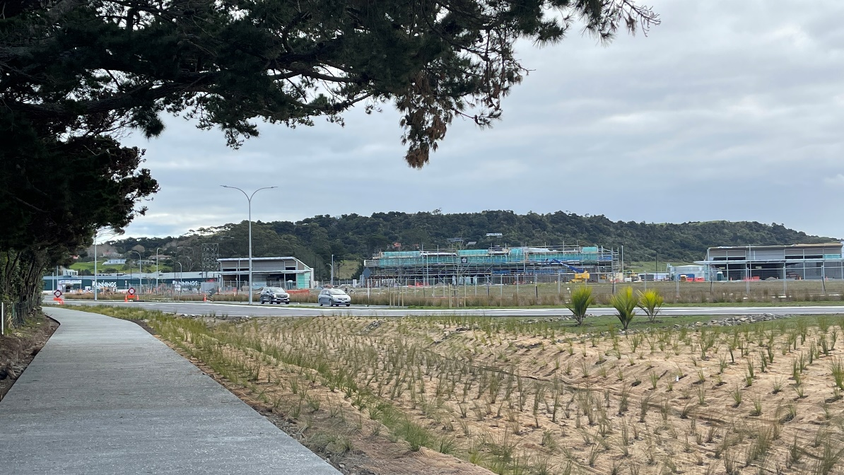

* Maintain standards for subdivision design and development (site size, minimum impervious areas, construction, and infrastructure) that will minimise sediment and contaminant deposition in local waterways and the harbour.

**2: Sustainable Town Growth**

* **Minimum Lot Size**

1. Amend the Medium Density Residential Zone lot size from 400m2 to 500m2 and apply only to planned higher density areas such as Managwhai Central or to sites in the immediate proximity (e.g., 250m) of retail and commercial centres in the Village or Wood Street;

AND

1. Apply the Low Density Residential zone (750m2 minimum lot size) to the balance of the residential land at Mangawhai Village and retain at Mangawhai Heads;

TO:

* Protect the environment (stormwater management, planting);
* Be sustainable (providing for rainwater storage sufficient to enable households to cope with prolonged dry periods);
* Accommodate residential and holidaymaker needs for on-site vehicle and recreational boat and other watercraft storage;
* Facilitate on-site vehicle manoeuvring provide for a safe interface with the road corridor.
* **More diverse Subdivision site sizes and dwelling density**

Provide for greater diversity in housing through the adoption of more flexible subdivision rules.

* The site size provisions of 400m2 to 1,000 m2 for urban subdivision are too small and the range too narrow to enable diverse residential development and do not give effect to policies (both existing and required) regarding infrastructure, biodiversity, water quality, settlement character, and landscape values.
* 400m2 is too small for sites and should be a minimum of 500m2 (outside Integrated Residential Developments) as at Mangawhai Central, while 1,000 m2 is too small for large lots and should be 4,000 m2, except where clustering and vegetation management plans justify a Development Agreement (of, for example, an average lot density of 2,000 m2), and applied to landscape and biodiversity sensitive areas. Some of these landscape amenity areas appeared in the Mangawhai Spatial Plan December 2019 as “large residential sites” but have not been carried though into the Exposure Draft (see below).

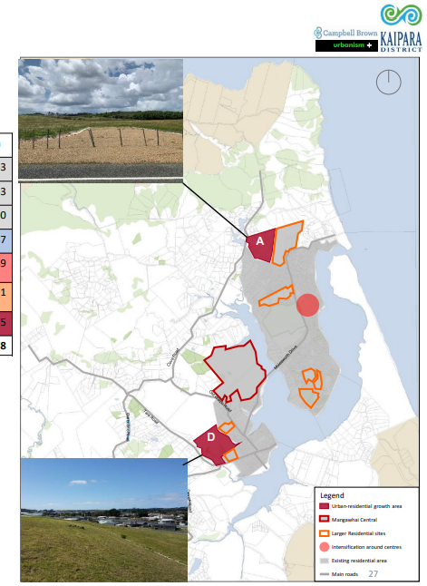

* Provide additional capacity for employment (including provisions for working from home);
* Review rules and extend options for Integrated Residential Development;
* Delete Retirement Villages as a separate form of Integrated Residential Development;
* Ensure adequate corridor provision for mixed transport modes (private vehicle, mobility units, bicycles, pedestrian,) and parking and manoeuvring of vehicles;
* Reserve future road reservations (e.g., Old Waipu Rd) and where necessary increase corridor width to provide for multiple transport modes to cater for growth;
* Establish rules for package sewerage plants and disposal fields (wetlands) for individual subdivisions.

**3: Rural Settlement**

**Rural Lifestyle Zone** The proposed rural lifestyle zone and subdivision rules are generally supported, with the zone being focussed on existing towns. The minimum net average site area of 2ha and minimum net site area of 1ha is appropriate.

**However**, we consider that *some* areas where the Zone has been applied could be more appropriately zoned Large Lot Residential provided that the Large Lot Residential zone have a 4,000m2 minimum site area.

These are areas that are within (say) 2km of urban zoned land and which already have a small lot character and are relatively close to commercial, education and recreational services in Mangawhai Village and the Heads. Environmental values should be maintained at both subdivision and development through applying the appropriate standards. This could be considered (for example):

* Land up to and to the west of and generally accessed from Devich Road near the Village; and
* Land on and accessed from Cove Road.

This would partially offset limits on growth capacity arising from increasing minimum residential site sizes and from infrastructure limitations in the towns, accepting that rural settlement will continue to underpin much of Kaipara’s growth east of SH1 by way of demand for sites which are more manageable for most people than Rural Lifestyle zone sites. Conversely, providing 4,000m2 sites in peri-urban locations will preserve Rural Lifestyle zoned land for people who wish to undertake more self-sufficient farming or intensive rural production enabled by larger sites of 1ha to 2+ha.

**Rural Production and General Rural Zones**

There is no clear justification for both a Rural Production and a General Rural zone. Combining them will remove duplication and reduce uncertainty. We support the need to protect high quality soils for production purposes but consider that this can be achieved through appropriate policies, activity rules, and standards, referring to land use activities and subdivision, for example.

We suggest that the rules provide for the following:

* The subdivision of any site where the resulting lots are 100 ha or larger;
* The subdivision of one lot of between 1ha and 2ha from any site of 20 hectares or larger existing on the date of notification of the Plan (this ensures that a subdivision can only occur once);
* Maintain the environmental benefit subdivision rule, including the minimum site area of 1ha, but delete the requirement for a balance lot to be greater than 20ha when 2ha would suffice. A 20ha minimum balance makes little sense from a production perspective, unless on prime soils. In those cases, an appropriate minimum area or maximum proportion of the site might be specified.

The challenge is to balance biodiversity and freshwater management with productive soils policies. One option may be to make subdivision where there is more than (say) 5ha of prime soils a discretionary activity subject to assessment and a merit-based consent decision.

In summary, any rural site should be eligible to take advantage of this rule (which typically protects biodiversity and water quality), with the number of sites and balance areas governed by the specified areas of significance. The rule should also clearly require that the area of the site containing the significant environmental benefit area must be (say) 5,000m2 or larger, for dwellings and curtilage, other than where elite or high-quality soils are involved and a larger balance area required if included in the environmental benefit site itself.

**Attachment One: Extracts from Mangawhai Community Plan Documents[3]**

**Mangawhai Town Plan Land Development and Density**

**Kaipara District Council**

**Introduction** - Ten Growth Principles (pp2-3):

(1) Mangawhai will continue to rely upon rainwater collection and tank storage. While the potential for a reticulated water supply for Mangawhai is being investigated, it is likely that full reticulation will be unfeasible, although there may be scope for community-based schemes or communal water supplies for firefighting purposes.

(2) Medium density living will be encouraged around the key nodes of Mangawhai Village, Wood Street shopping centre and Estuary Estates Council is under increasing pressure from developers to consent smaller lots for buyers who desire low maintenance holiday houses. Rather than permit such development in an ad hoc fashion, it is proposed to concentrate medium density living around activity nodes.

(3) Application of a town boundary There is sufficient surplus undeveloped land within the existing Residential Zone, defined by the Kaipara District Plan, to accommodate residential growth in Mangawhai so that the zone boundary only requires minor adjustments in certain areas.

(4) Lifestyle block development will be directed to a sub-zone of land surrounding Mangawhai Lifestyle block subdivision has been the dominant trend in Mangawhai in recent years. It is proposed to introduce a rural/residential or rural/lifestyle zone for a belt of land around Mangawhai to direct and accommodate such development.

(5) Urban design standards will be introduced to manage medium density development The best practice principles of urban design will inform the MTP and urban design standards will form part of the project to manage the effects of medium density development.

(6) Roads will be used to define public space Roadways and the assets within them, such as footpaths and planting, inform the usability and character of public space. The project will review how existing roads define public space and how cost-effective improvements can be made.

(7) Improving walking and cycling uptake and connectivity will be a priority The majority of Mangawhai residents and visitors use cars to move around the area. This is due to poor connectivity between existing footpaths and the lack of cycling facilities. The project will advocate for improving connectivity through infrastructure spending and medium density development around existing nodes.

(8) Population growth will not be matched by increase in roading capacity Rather than catering for growth by expanding the roading network it is assumed that road improvements and more walking and cycling will replace local traffic movements.

(9) Environmentally sustainable design will be encouraged in Council and private developments. Low impact stormwater design, walking and cycling, improving biodiversity through planting and weed control and recognising and improvements in public spaces will be advocated for in the project.

(10) Partnerships with community groups, developers and businesses are vital to the future of Mangawhai. The MTP will only be successful if it recognises existing partnerships between Council and the community and other key stakeholders, involves public consultation and encourages further collaboration with volunteer groups, property developers and business owners.

**Mangawhai Town Plan URBAN DESIGN STUDY PHASE 1**

Opus International Consultants

**Key elements that contribute to Mangawhai’s character, amenity, and aesthetic coherence** (pp10-14)

**High level of natural character**

* Mangawhai Harbour and coastline, Barrier Spit, and surrounding parkland, recreational and rural settings provide the backdrop to and are visible from within the residential areas.
* Public open spaces including Alamar Reserve and the esplanade reserves along the harbour edge give a sense of openness and natural amenity.
* A high level of natural amenity in streetscapes from:
  + Established, native and coastal planting in private front and side yards, especially in older areas. Provides for privacy without the need for fencing.
  + Informally grassed/shared surface road and footpaths, with natural stormwater swales in new streets.
  + Large areas of mature, native, and exotic vegetation, particularly where topography undulates.

**Sense of openness / community**

* ‘Unwritten rules’ that existing community understands and values.
* No, low or permeable boundary treatment.
* Continuation of grassed road verge into private front yard.
* No or ‘low-key’ delineation between public and private realm and from one property to another. ‘Porosity’ or property.
* Open decking facing street/public realm.
* Main windows facing street/public realm.
* Garaging at side/rear or absent.
* High level of natural surveillance.
* All contributing to sense of openness and ownership of the street and public realm, a high level of natural surveillance and a strong community feel.

**Informal ‘bach’ aesthetic**

* Modest roof design - mono and dual pitch roofing most common.
* Natural timbers, board and batten, and weatherboarding prevalent.
* Muted/natural/recessive/coastal colour scheme, looking to/reflecting surrounding natural environment (light greys, whites, fauns, light blues).
* Natural treatment of driveways and parking areas common including use of grass, natural paving, gravel, shell, and exposed aggregate.

**Low scale height and massing**

* Buildings not imposing on the streetscape.
* One to two storeys in height.
* Two storey buildings tending to be on steeper properties and/or to maximise coastal/rural views.
* Ground floor often recessed back, and second floor articulated with cantilevered deck, differentiating between floors, and breaking up form and massing of the building.
* Buildings not ‘crowded’ - set back from street, separation between dwellings, low building site coverage.

**Attachment Two: Population Potential**

The differences between the Operative District plan and the exposure draft are summarised in the table provided by the KDC District Plan Team:



The residential capacity has been calculated based on the areas associated with the different residential zones, a 70% yield of useable land, and representative “average” lot size based on the relevant density rules. The potential population numbers assume all lots are occupied with an average household size of 2.5 persons (Low) and 3.0 (High). The latter figure could well be exceeded in the summer peak. No provision has been made for integrated residential developments.

The reality is that this level of development may never be achieved given the constraints and contingencies facing Mangawhai. It will not be approached within the life of the proposed plan.

However, the figures provide grounds for testing the sustainability (and costs) of the long-term growth potential provided for.

**Estimating Population Potential**



**Employment Implications**

It is reasonable to expect that long-term provision for commercial activity and employment will be approximately balanced with expectations for population growth. Based on the two estimates of total population above expectations can be set for labour force growth – essentially, the demand for new jobs.

At a low participation rate and the lower density uptake of residential capacity provided for in the Exposure Draft, we could reasonably expect the active working population to expand by 7,100 people.



The provision of business land[4], however, even with historical employment densities – which can be expected to continue to decline – would accommodate no more than 2,000 jobs and most likely significantly less.



While the future form of work – the mix of jobs, how and where they are undertaken – is uncertain, and the nature of household-oriented retailing and service activity is changing, the provisions for industry and commerce appear well short of the need that would arise if the residential capacity provided for is taken up. Even if 50% of total jobs were performed from home – providing the residential zones allow it – the imbalance is substantial.

1. High-capacity roads of this kind significantly affect residential and open space amenities and are a major barrier for pedestrians and cyclists
2. This ridge is currently suggested as Medium Density Residential which permits 400m2 sites. With such zoning (and no ridgeline protection rules) it is inevitable that almost all trees on this ridge will be felled and intensive residential development will dominate the visual catchment. The adverse aesthetic and biodiversity consequences of such an omission are evident on the ridgeline of Seacoast Rd at Mangawhai Heads.
3. In draft
4. The figures are based on the shift from the ODP to the Exposure Draft indicated in the table and 5.32ha of the Business and 8.03ha of the Services zones in Mangawhai Central.